**Requirement document :**

|  |  |
| --- | --- |
| Version | Date |
| Verion 1.0 | **29/09/18** |

**Desing :** Develop mobile responsive registration page with following features:

Screen

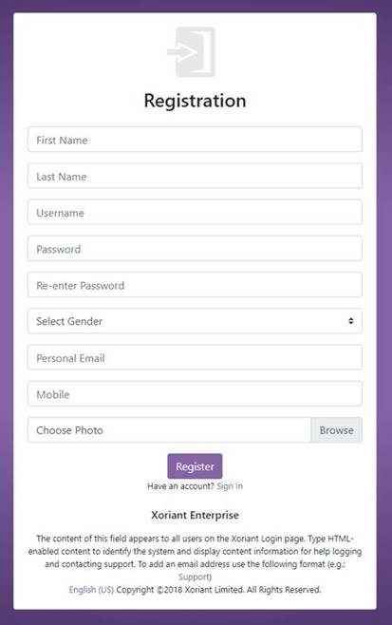

* Design responsive UI as given in the mockup above, the page content and elements should automatically adjusted for optimal viewing based on devices such as **phone, tablet, desktop etc.,**
* **On successful save a message should be displayed on top of “Registration” label in green color.**
* Implement following knockout validations on mandatory fields
* Username - should not be empty and must not special characters ([ ] : ; | = , + * ? < >, space)
* Password should be Re-enter password
* Password must be at least 9 characters and include: 1 Special character (!@#$%^&*()<>?\) , out of 8 characters 1
* If email is provided then it should be validated for email format
* If mobile is provided then it should be validated for mobile format(10 digit with country code)

**Database:**

* Design database schema to store UI information.
  + On clicking the Register button, the entered details should be saved to the DB

**Backend**

* Create following files to maintain respective layer code
* CSHTML – to maintain the UI
* JavaScript – to maintain client scripting code
* Controller - server side code
* Business Logic -server side code
* Repository - server side code
* Technologies :Bootstrapv4.0, Knockout, jQuery, ASP.Net MVC, Entity Framework.